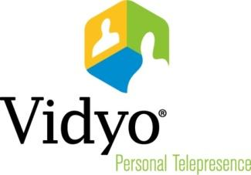



6/29/2015



433 Hackensack Ave   
Hackensack, NJ 07601 USA

©2011 – 2013 Vidyo, Inc. All Rights Reserved. | Patent <http://www.vidyo.com/about/patent-notices/> | VIDYO, the VIDYO logo and the VIDYO family of product marks are trademarks of Vidyo, Inc. All other trademarks are the property of their respective owners. All specifications subject to change without notice; system specifics may vary. All images are for representational purposes only; actual products may differ.

Table of Contents

**Chapter 1: Welcome 3**

Introducing … 4

How to install it … 5

Log in… 6

Contacts… 7

Conference Rooms… 8

Configuration… 13

# Welcome

## Introducing…

VidyoDesktop is the desktop product of Vidyo. It enables you to easily join Vidyo calls, either as a guest or as a registered user, make point-to-point calls, invite others to your meetings, and control your Vidyo conferencing experience all from a single application with an intuitive user interface. This product can be used on Windows, Mac and Linux OSs.

In this guide you will learn the app's basic functionalities, features, etc.

## How to install it?

* The easiest way is to download the installer from the portal.

Go to the portal URL and click to download the build that is uploaded to the portal.

For example: <https://qa.demo2.vidyo.com>.

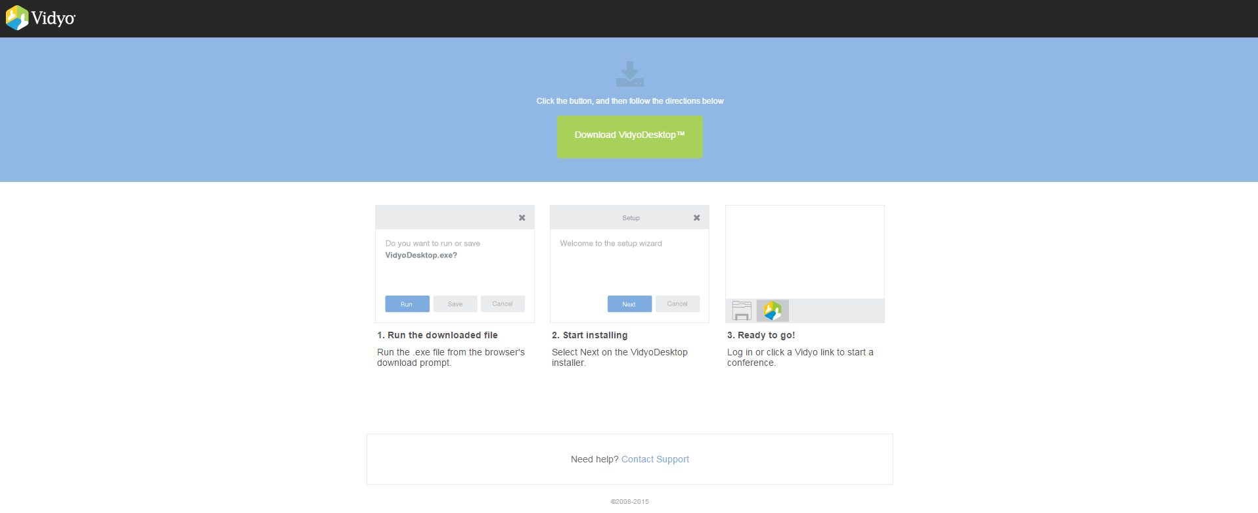

* Another way is to access the Installer folders: \\server\images\Hunter\VidyoDesktop\Installers

Another way is downloading the installation file from the server folder.

The VidyoDesktop installers are located at \\server\images\Hunter\VidyoDesktop\Installers.

To execute this faster, copy the file to your machine and then run it.

## Log in

When you run VidyoDesktop, you will need to enter the portal URL and a valid username and password (that was previously created in the portal interface).

For example:

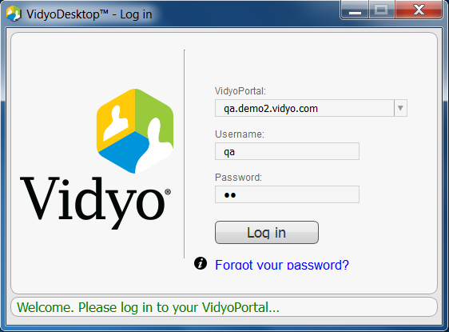

## Contacts

The contacts page contains the list of all the 'favorite' contacts chosen by the user.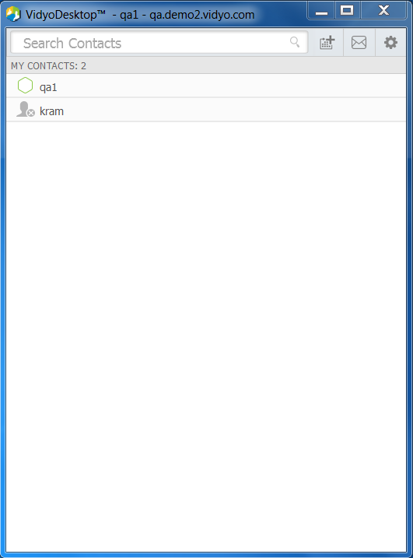









1. While searching a contact, you search the results in the DB of the specific portal you are logged in to. You can user different search criteria – you can search a user by display name, by user name, by initials. You can also search for a conference room with its name or extension.
2. The number of contacts in your contact list.
3. The 'wheel' icon is used to open the configuration window.
4. You can invite others to join your room by email simply clicking the 'envelope' icon.
5. You can also schedule appointments by simply clicking the 'calendar' icon.

In order to add a contact to the favorites list, search its name and click on the yellow plus next to it - .

## Conference Rooms

### Your Own Conference Room

### 

### 

### 

Your personal room is always the first in the list of contacts.

1. The status of the room, the room's owner, the room's extension, and the tenant name.
2. Click **Connect to your Room** to join your room.
3. Select the Share screen upon connection check box if you want to share your screen with the rest of the participants as soon as you join the conference.
4. The number of participants in your room.
5. Click the mic/camera/speaker if you want your camera, microphone, and/or speaker to be muted when you join the conference.
6. Click to lock your room. No other participant will be able to join your room after it has been locked.
7. Click to invite guests to your Vidyo meeting. When you do so, the meeting invitation automatically opens using your default desktop mail application, and pre-fills with your personal Vidyo room information. You can enter the email addresses of the guests you want to invite to the meeting or edit the email content before sending.
8. Click to access the Room Details pop-up. The Room Details pop-up enables you to enter a room, webcast, or moderator PIN, or copy the room or webcast link so you can send it to others.

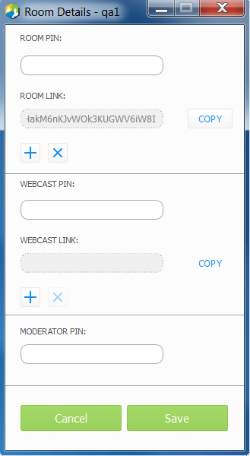

### Connecting to a Contact's Room or Connecting to a Contact Directly

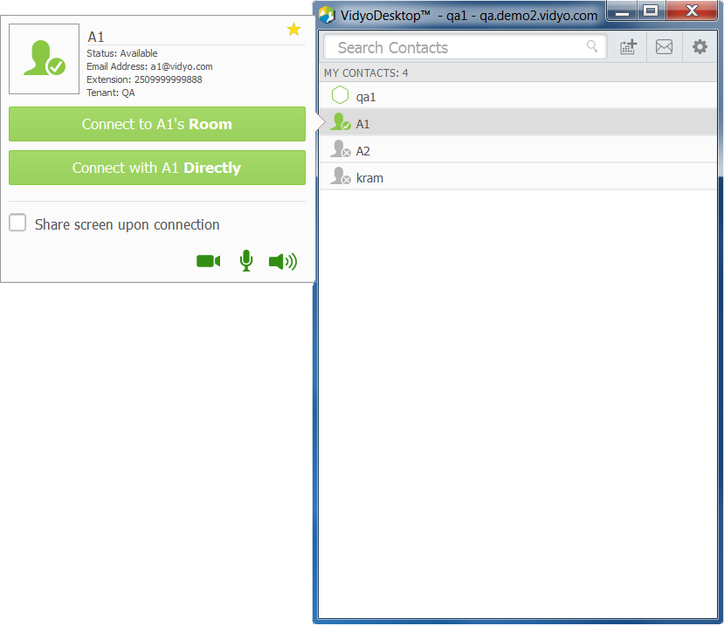



Most of the behavior is the same as in joining your own conference room, except for:

1. Click to remove this contact from your contacts list.
2. Click **Connect** **with <username> Directly** to place a direct call (P2P).

If this contact is in a busy or offline state, this button will be disabled.

### Placing an External Call

### 

### 

### 

1. Since these contacts are not in your directory, the only status available is that they are external contacts and are the room owner.
2. If you are calling a non-Vidyo system (a legacy H.323/SIP endpoint), tap **Call** to place a direct call to that endpoint.
3. If you are joining an external Vidyo conference on another VidyoPortal, tap **Join Room** to join that room.

The **Join Room** button appears only if the address you entered is in a valid format for an address on a different VidyoPortal.

### Status Icons

**Contact Status**

 This is the icon that indicates that the contact is online and available to receive a direct call or to join a room.

 This icon indicates that the contact is online but is currently in a call or conference. You cannot make a direct call to this contact. However, you can join the contact's conference room.

 This icon indicates that the contact is offline (not logged into the VidyoPortal). You cannot make a direct call to this contact. However, you can join the contact's room.

### **Room Status**

 This icon indicates that this room is available and empty, so you can enter the room.

 This icon indicates that the room is available and PIN-protected. If you attempt to join the room, you will be asked to enter a PIN.

 This icon indicated that the room is occupied but available to enter.

 This icon indicates that the room is locked. You cannot enter the room.

 This icon indicated that this room is full, so you cannot enter it.

## Configuration

### Status

The status TAB shows the information about the user's status (for example: whether the user is logged in or not, whether the user is in a conference or not).

### **Conference Status**

Clicking on 'Show Conference Status' opens an informative window with all the conference data – available bandwidth, video resolution and FPS, CPU, etc…

This option is only available when the user is in a conference room.

### **Generate Diagnostics Report**

Clicking on 'Generate Diagnostics Report' locates the logs file on your machine's desktop.

### Network

The network TAB shows info

### **VidyoPortal:**

* Select the Validate Server Certificate check box only if you are testing encryption with a self-signed certificate. Otherwise, do not select this check box.
* Enter the allowed media port range (between 50000 and 65535).

**VidyoProxy:**

Select the Always use VidyoProxy check box if you want VidyoDesktop to always connect via the assigned VidyoProxy. Vidyo recommends that you try to connect directly.

**Web Proxy:**

* Select the Use settings from operating system check box if you want VidyoDesktop to follow the Internet Explorer Local Area Network settings on Windows or the OS settings on Mac.
* Otherwise, select the Use the following settings check box and then select:
* Automatically detect settings to configure VidyoDesktop to try to connect using WPAD (Web Proxy Auto-Discovery Protocol).
* Use automatic configuration script to configure VidyoDesktop to use a specific PAC script for connection.
* Use proxy server to configure VidyoDesktop to connect through a specific Web Proxy server. If you select this check box, enter the Web Proxy address, port, username, and password.

If you are trying to connect to a Web Proxy that requires authentication, you must enter the username and password regardless of the selected method. Note: For help with configuring your network settings, talk to your system administrator.

### Devices

This TAB allows you to select the microphone, speaker, and camera you are using, control echo cancellation and set whether you want the microphone level to be automatically adjusted.

### Video

This TAB allows you to select which video quality you want to use.

### Options

This TAB allows you to select the language of the user interface, whether you want VidyoDesktop to automatically start when you log in, whether you want VidyoDesktop to automatically answer incoming calls, and more.